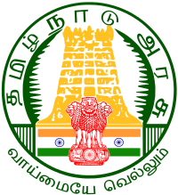

SPECTRUM
ECHO OF DIET SALEM
EE
Ece

Uthamacholpuram-636010
AUGUST - 2021 PREPARED BY: ET VOL: 4 NO: 7



EAT RIGHT INDIA
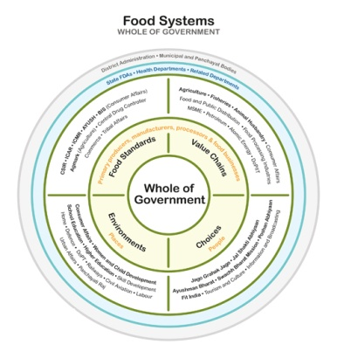
In the preamble to the food safety and standards act, 2006, the food safety and standards authority of India (FSSAI) is expected to ensure availability of safe and wholesome food for the people in India. Therefore, fssai has embarked on a large-scale effort to transform the country’s food system in order to ensure safe, healthy and sustainable food for all Indians through the ‘Eat Right India’ movement. The tagline ‘Sahibhojan. Behtarjeevan’, thus, forms the foundation of this movement.

Eat Right India Adopts A Judicious Mix Of Regulatory, Capacity Building, Collaborative And Empowerment Approaches To Ensure That Our Food Is Good Both For The People And The Planet. Further, It Builds On The Collective Action Of All Stakeholders - The Government, Food Businesses, Civil Society Organizations, Experts And Professionals, Development Agencies And Citizens At Large.
Eat Right India Adopts An Integrative Or ‘Whole Of The Government’ Approach Since The Movement Brings Together Food-Related Mandates Of The Agriculture, Health, Environment And Other Ministries.
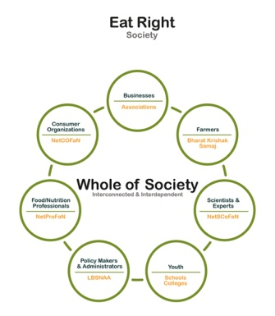
Furthermore, Since Food bore Illnesses And Various Diet-Related Diseases Cut across All Age Groups and All Sections of the Society It Also Adopts A ‘Whole Of Society’ Approach, Bringing All Stakeholders Together On A Common Platform.
Eat Right India Is Aligned To the National Health Policy 2017 With Its Focus On Preventive And Promotive Healthcare And Flagship Programmes Like Ayushman Bharat, POSHAN Abhiyaan, Anemia Mukt Bharat And Swacch Bharat Mission.
Dr M.Sevalm, Principal
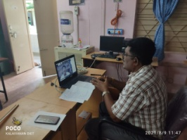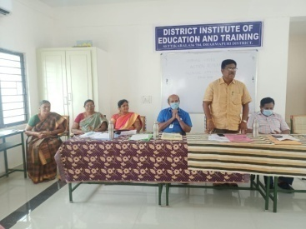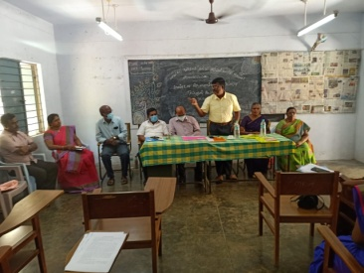
PRE - SERVICE TEACHER EDUCATION :( PSTE)
P.GOVINDA PRAKASH, SENIOR LECTURER
- 2.8.21 -AR-Documentation Surya Press.
- 4.8.21- AR Topic Preparation.
- 5.8.21- Office Work CEO Meeting.
- 6.8.21- AR Topic Selection Principal Meeting.
- 7.8.21 – DOE Work.
- 9.8.21 to 10.8.21 -AR Project Collection Work, DGE Work.
- 11.8.21- AR Zoom Meeting DGE Work.
- 12.8.21-AR Uploading Work.
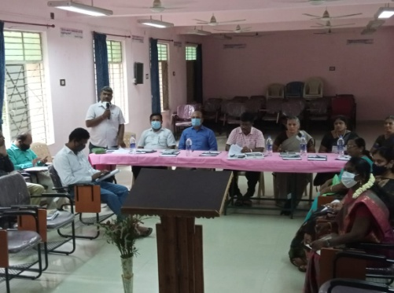
- 13.8.21-AR Uploading Work, Independence Day Celebration Work.
- 15.8.21 -Holiday, Independence Day Celebration.
- 16.8.21 -AR Uploading Work.
- 17.8.21 to 18.8.21 - AR Consolidation Work.
- 19.8.21-Research Work.
- 23.8.21-Research Work.
- 24.8.21 to 25.8.21 -AR-Google Form Uploading.
- 26.8.21 To 27.8.21 – GHS- Neikkarapatti .
- 28.8.21 - ZARC-Salem.
- 31.8.21 - G.H.S Neikkarapatti.
S.PETTER ANANDH, LECTURER
- 2.8.21 - Research Preliminary Work
- 3.8.21 To 4.8.21- AR proposal preparation
- 6.8.21– AR Proposal Presentation
- 9.8.21 To 11.8.21-Yoga Video Shooting Diet
- 12.8.21-Yoga Training Document Preparation
- 13.8.21-Yoga Training Document Completion
- 16.8.21-Research Project Proprietary Work

S.SELVI- LECTURER.
- 07.08.2021- D. El .Ed Arrear Student Certificate Verification at DIET.
- 10.08.2021- D. El. Ed Arrear Student Certificate Verification at DIET.
- 13.08.2021-D. El. Ed Arrear Student Certificate Verification at DIET.
- 17.8.21 - AR Work.

R.RAVI- LECTURER
- 07.08.2021- D. El. Ed Arrear Student Certificate Verification at DIET.
- 10.08.2021- D. El. Ed Arrear Student Certificate Verification at DIET.
- 13.08.2021 - D. El. Ed Arrear Student Certificate Verification at DIET.
- 17.8.21 - AR Work.
- 26.08.2021- 28.8.21-ZARC-Action Research Proposal Presentation.
- 31.08.2021-Visited GHSS NADUPPATTI, GHS POMMINAIKAMPATTI.AT KADAYAMPATTI BLOCK.

IN-SERVICE FIELD INTERACTION INNOVATION AND COORDINATION :( IFIC)
K. RAMESH KUMAR, LECTURER

- 9.8.21- PG -Zoology– Digital Module-Unit-6.
- 11.8.21-PG –Zoology- Digital Module.
- 16.8.21 -Digital Module Preparation- Bio- Zoo.
- 17.8.21 – PG Digital Module Preparation- Basic Electronics Engineering.
- 18.8.21- PG Training Module Preparation and AR Proposal Preparation.
- 19.8.21 -PG-Zoology Module Zoo Preparation.

- 20.8.21-Moharam -Government Holiday.
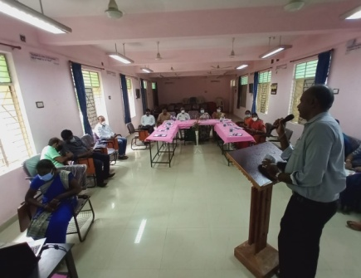
- 23.8.21-Bio- Zoo Model 5 Preparation, Research Proposal.
- 24.8.21-PG - BEE and Zoo Module, Research Meeting.
- 25.8.21 -PG Digital Module Correction.
- 26.8.21- PG Module 1 Question Re-typing 1-4- Correction.
- 27.8.41 -Easy Model Video Editing Work (OD).
- 28.8.21-ZAARC &PG Module Bio Zoom Unit 4.
- 31.8.21- PG Training Module Preparation Work.

M. MAHALAKSHMI, LECTURER

- 2.8.21- Assessment Tool Bill Preparation And Google Meet By JD Mam Regarding Assessment Tool Preparation.
- 5.8.21- Assessment Question Preparation for Chapter 2 In 6th Math.
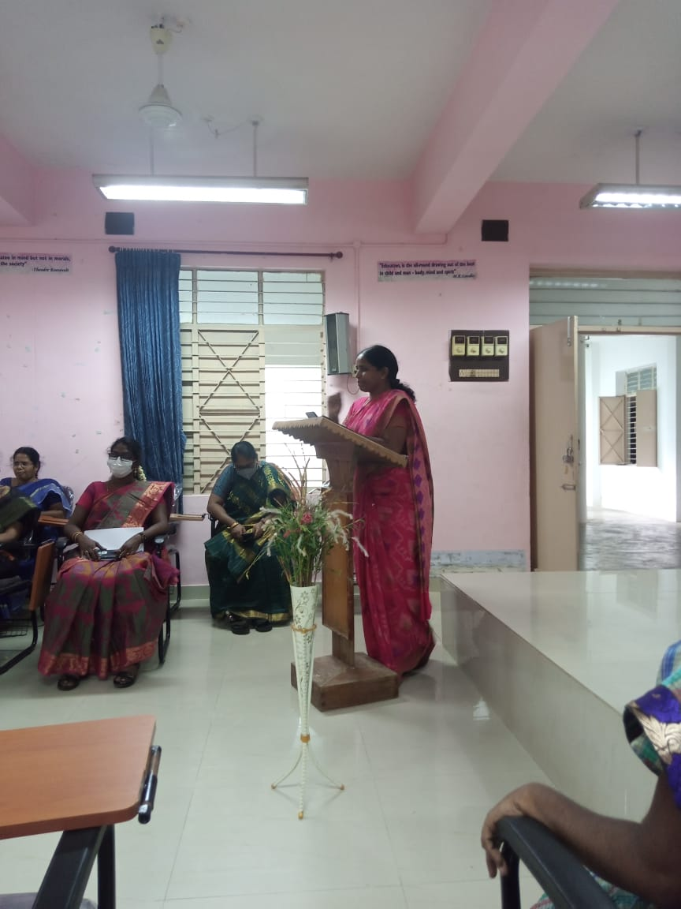
- 6.8.21- Assessment Question For 6th Math Term 1 Chapter 2 Preparation Send Mail.
- 9.8.21- Assessment Question Preparation For 6th Standard First Term 2nd Lesson.
- 10.8.21- Assessment Question Preparation For 6th Standard First Term 3rd Lesson.
- 11.8.21- Research Project Topic Preparation and Aptitude Question Preparation Meeting In Google Meet.
- 12.8.21- Assessment Question Preparation for 6th Math for Term – I
- 16.8.21- Assessment Question Preparation.
- 17.8.21 –In Service Work Budget Reframing Work Assessment Question Typing.
- 18.8.21- Training Document Preparation at Diet.
- 19.8.21- Assessment Question Preparation for VI Std at DIET.
- 24.8.21-Training Document Preparation.
- 25.8.21- DGE Work Paper Stitching Work at GHSS, Neikarapatti.
- 26.8.21- Action Research Proposal Preparation.
- 27.8.21- ZARC-Preparatory Work and School Visit GHSS Valasaiyur.
- 28.8.21-ZARC-Action Research Proposal Presentation.

EDUCATIONAL TECHNOLOGY BRANCH: (E.T)
G, DHANAMMAL, SENIOR LECTURER
- 2.8.21 to 3.8.21 - Internal Assessment Work Online Mode, CSI, TTI –Hasthampatty.
- 5.8.21-Internal Assessment Work Online Mode - CSI, TTI – Hasthampatty.
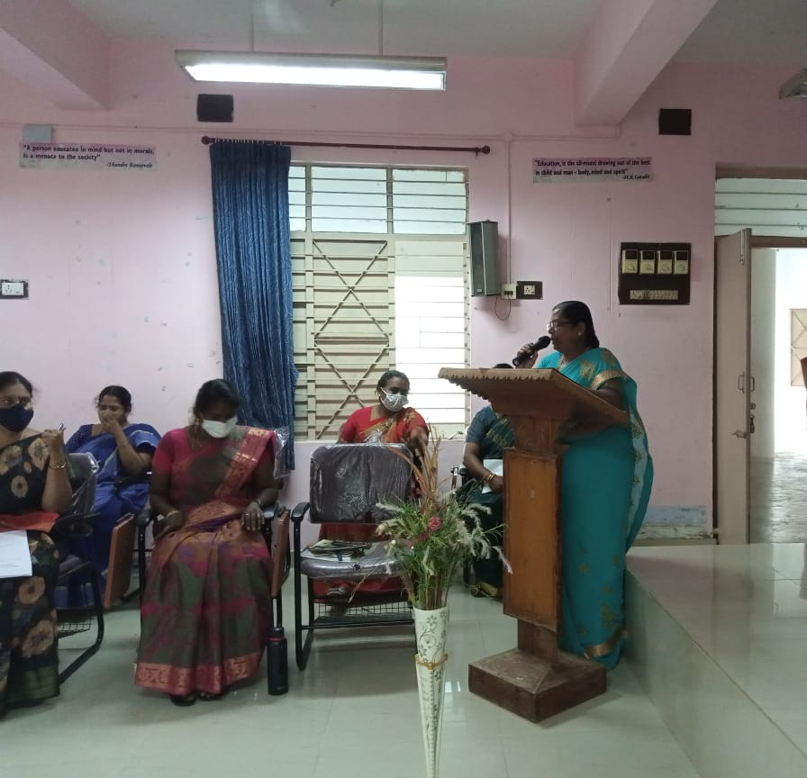
- 9.8.21 to 13.8.21-Action Research Proposal For Preparation.
- 16.8.21 to 17.821-Attend Staff Meeting AR Proposal To Google Form Regarding.
- 23.8.21 to 25.8.21 -Action Research Proposal Uploaded to Google Form.
- 26.8.21-ZARC-Member Acted as Coordinator, DIET Krishnagiri.
- 27.8.21-ZARC- Member Acted as Coordinator DIET Dharmapuri.
- 28.8.21- ZARC -Submitted The Action Research Proposal.
- 31.8.21-ZARC-Member Acted as Coordinator DIET Ranipet.
V. SUGANYA, LECTURER
- 2.8.21 -BCE XI & XII Assessment and Project Title Preparation.
- 3.8.21- Local Holiday.
- 4.8.21 –Attending JD Syllabus Meeting Regarding Assignment And Internal.
- 9.8.21-PSTE Work, News Letter Preparation.
- 10.8.21- BCE -Unit-3 Assignment Consolidated And Send To SCERT,
- Internal Assessment.
- 11.8.21 to 14.8.21-TRB Chennai Confidential Work.
- 16.8.21-D/W XI, XII – BCE Assessment Question Setting Unit 4.
- 17.8.21-Swayam Assignment XI & XII - Unit 5 BCE Assignment Question for The Nation And Send To SCERT.
- 18.8.21 -Re Internal Assignment St. Joseph TTI (2 Girls).
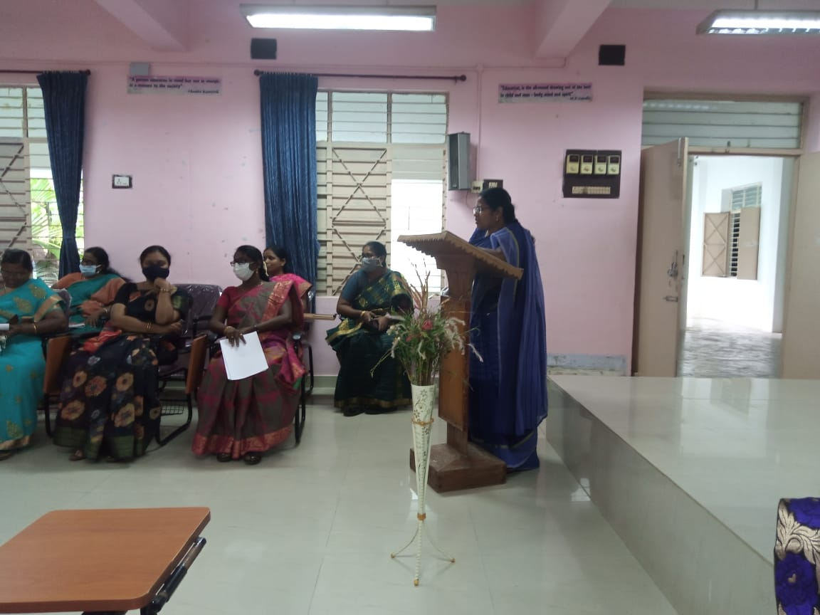
- 19.8.21-AR Proposal and Project Proposal Preparation.
- 24.8.21-Assignment Questions XI & XII BCE Preparation, AR Uploaded To Google Form, Attended Staff Meeting Regarding AR & Project.
- 25.8.21 Refresher Course Module XII-BCE Coordination and Send To SCERT, Question Typing.
- 26.8.21-Oct 2020 News Letter Preparation
- 27.8.21-School Visit Sop, MHS-Old Suramangalam, GHSS-Joriammapalayam
- 28.8.21 - ZARC-AR Proposal Presentation
- 31.8.21 – Sop SV-GHSS Ayodhyapatnam, GHS Mansi Naikanpati , GHS KN Colony.

M.JAYAMANI ,LECTURER
- 2.8.21 To 4.8.21-AR Proposal News Letter
- 9.8.21-பிழைக்களைதல்.
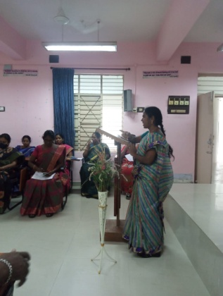
- 16.8.21 to 17.8.21 News Letter Consolidation Work.
- 18.8.21 to 19.8.21-Action Research Proposal.
- 23.8.21-Principal Meeting எழில்மிகுஅலுவலகம்
- 23.8.21- AR Proposal Uploaded.
- 24.8.21- AR proposal Uploaded And Meeting For AR.
- 25.8.21-AR Proposal Correction work
- 26.8.21-AR Proposal sbmission
- 27.8.21- GHSS சிவதாபுரம் GHS பெரியபுத்தூர்பள்ளி பணி சார்ந்தது.
- 28.8.21-ZARK Meetings For AR Proposal
- 31.8.21 – எடப்பாடி GBHSS எடப்பாடி.

DISTRICT RESOURCE UNIT: (DRU)
- Second One Third Of Unit MCQ Preparation Both Tamil And English Medium Coordination
NAME OF THE DIET FACULTY : Dr P.SO.KESAVAN, DRU BRANCH

Date | DETAILS OF WORK CARRIED OUT
11.8.2021 | DIET: Action Research –Proposal Preparation.
12.8.2021 | DIET: List Of Faculty Joined In SWAYAM COURSE –CONSOLIDATION.
15.8.2021 | SUNDAY -Attended Independence Day Celebration.
16.8.2021 | DIET: Attended faculty meeting regarding action/research proposal submission in Google Form.
27.8.2021 | OD: School Visit- Went To Schools To Assess The Preparedness To Open The Schools.  FN:GHS,POOLAVARI  AN: MNSGGHSS, ATTAYAMPATTY.
28.8.2021 | 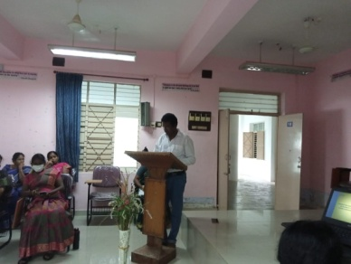  DIET: Attended ZARC -Action Research Proposal Approval Meeting And Presented Action Research Proposal.
31.8.2021 | OD: School Visit- Went To Schools To Assess The Preparedness To Open The Schools.  FN:GHS,PERIYAPUTHUR  AN:GHS,CHINNASEERAGPADI.

CURRICULUM MATERIAL DEVELOPMENT EVALUVATION :(CMDE)
Dr. R.NAGALAKSHMI, SENIOR LECTURER
1. MCQ For Chemistry Class 12 was prepared by a Workshop with Post Graduate Teachers From 02/08/2021 To 05/08/2021 In DIET Conference Hall.
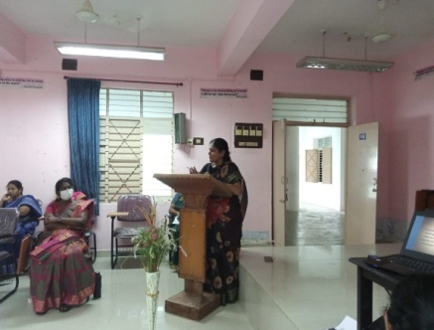
2. Attended Zoom Meeting for State Assessment Group-By JD regarding Higher Secondary Chemistry MCQ Preparation) On 25/08/2021.
3. Prepared And Mailed Refresher Course Module Work Plan For Higher Secondary Chemistry (State Level Plan) On 26/08/2021.
4. Presented Action Research Proposal In The Zonal Action Research Committee (ZARC) At DIET On 28/08/2021.
5. Compiled One Third Portions of MCQs in Higher Secondary Chemistry And Mailed.
6. COVID 19 SOP Visit to GHSS - Maniayanur.

B. ANANTHI, LECTURER
1. Attended 5 Days' Online NCERT- CIET's Webinar On "ICT Tools: Recommendations Of NEP2020: Use And Integration On Technology" - "Implementation Of Vision Of NEP 2020" From 09/08/2021 To 13/08/2021.
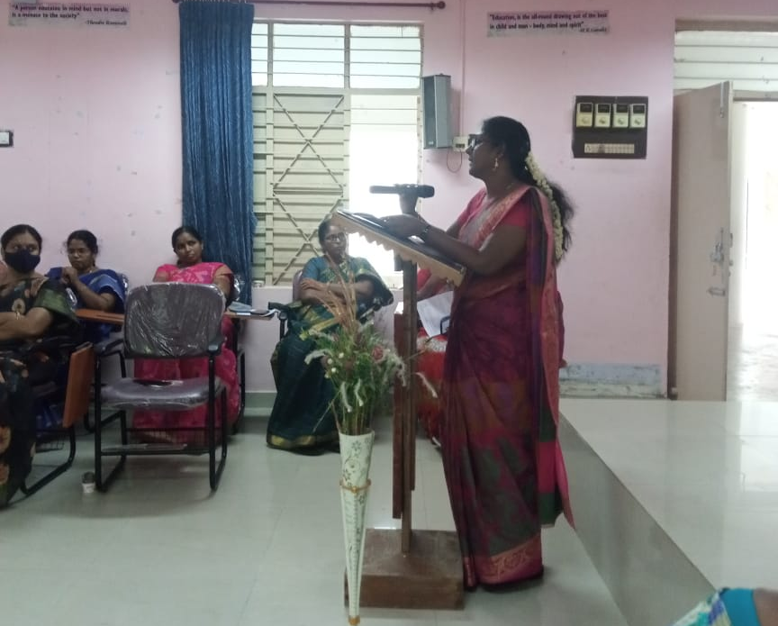
2. Attended Meeting Regarding 'Aptitude Test Questions Preparation", Conducted By JD (Syllabus), SCERT On 11/08/2021.
3. Action Research Proposal Preparation on 26/08/2021 & 27/08/2021.
4. Presented Action Research Proposal In The Zonal Action Research Committee (ZARC) At DIET On 28/08/2021.

PLANNING AND MANAGEMENT: (P&M)
K.KANNAKI, SENIOR LECTURER
August
- August Monthly Report.
- Attended The Google Meet JD Meeting Regarding Assessment Work.
- Preparation for 6th Standard Mathematics.
- Attended Principal Meeting Regarding Action Research Topic And Research Project Work.
- Simple Questions Preparation What For 6th Standard Unit 2 Lesson Algebra.
- 6th Standard Lesson Questions Preparation Work.
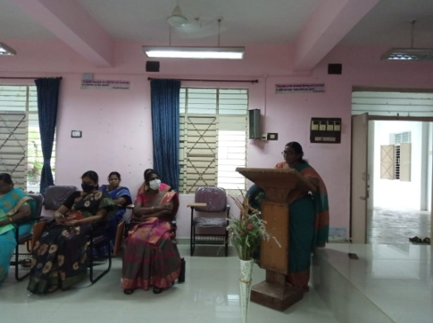
- Attended The Republic Day Celebration At DIET.
- Attend The Meeting Conducted By The Go In The Prakash Regarding Action Research Project Proposal Topic.
- Action Research Project Proposal Preparation Work Carry Over Are.
- Action Research Proposal Upload In Google Form.
- Attended the ZARC Committee Regarding Action Research.

B .UTHYAKUMAR, LECTURER

- .8.21 To 18.8.21 –Act As Coordinator for11th std Textile And Design MCQ Preparation.
- 19.8.21 Neikarappatty Anganwady Visit For District Specific Project.
- 23.8.21 AR Proposal Preparation .
- 24, 25, 26.8.21 11th Textile And Design Assignment Prepared To Sent SCERT Mrs. Nevatha .
- 27.8.21 SOP School Visit To GHSS Vaikundam .
- 28.8.21 Act As Coordinator For11th Textile And Design MCQ Preparation
- 31.8.21 SOP School Visit To Model GHSS Sankagiri.

WORK EXPERIENCE: (WE)

NAME OF THE DIET FACULTY: Dr S.V. VIJAYALAKMI SHANKAR,
SENIOR LECTURER, WE BRANCH
Date | ACTIVITIES
11.8.2021 | Joined The Duty. Studying SWAYAM COURSES.
12.8.2021 | Studying SWAYAM COURSES.
13.8.2021 | Studying SWAYAM COURSES.
16.8.2021 | NCERT -AR -Correction Work & Attended Principal Meeting.
17.8.2021 | NCERT -AR -Correction Work.
18.8.2021 | AR-Proposal Preparation Work.
19.8.2021 | Discussion About To Filling Of Research Project & Action Research Proposal In Google Form.
25.8.2021 | Preparation Of Work Done And Research Project Reviews.
26.8.2021 | Action Research Proposal Preparation Work.
27.8.2021 | Action Research Proposal Preparation Work And Went To School Visit To Check Availability Of Resources- Reopening Of Schools.  GHSS,Veerapondi: GHSS,Vembadithalam.  GBHSS, Ellampillai;Model School, Ellampillai.
28.8.2021 | Attended ZARC Meeting- Presented AR Proposal.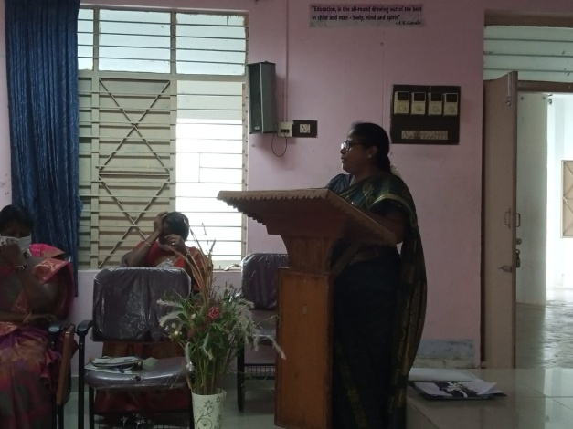
31.8.2021 | Collecting Reviews For Project Proposal.

C.ANBARASAN, LECTURER
- Coordinated Higher Secondary Textile Dress Designing Subject Module And Video Lesson Prepared.
- Prepared 200 MCQ Higher Secondary +2 Chemistry Subject In Each Unit.

K.KALAIVANAN, LECTURER
09.08,21 | Presented About Webinar on “World Education’’ at DIET for Teachers.
19.08.21 to 20.08.21 | BCE Assessment Work
27.08.21 | Schools Re-Open Visit.

Chief Editor : Dr M.SELVAM, PRINCIPAL
UTHAMACHOLAPURAM,
SALEM-636010
Associate Editors : G.DHANAMMAL (SL),
Mrs .M.Jayamani (L),
Editor : Mrs. S.Selvi(L)
This Newsletter is Prepared and Published by ET Branch
Phone : 0427-2273751
e-mail : dietslm@gmail.com
Visit : www.dietsalem.in

