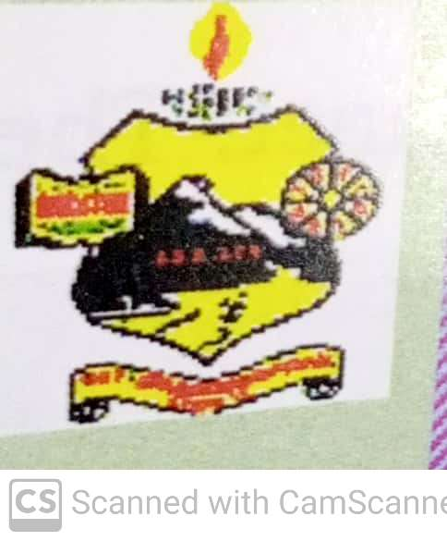

MAY -JUNE- 2021 PREPARED BY: ET VOL: 4 NO: 5

ECHO OF DIET SALEM
EE
Ece

Critical Pedagogy

Critical pedagogy in school
Critical philosophy is a progressive curriculum, where children examine social inequalities and injustices. They create a discourse around them, leading to action. It would require a whole social revolution to change society. But yes, we as teachers have the power of beginning it in the classroom, if not in the cradle. So here are a few things we as teachers can do!
Career development
Encourage girls and boys to dream of careers in professions which are challenging. Read books about women achievers in the classroom. Invite women achievers to talk to them, especially those who are part of the society around the school: women working in banks, as drivers, as entrepreneurs, as scientists, business women, sports, art, music... Create role models which they can follow.
Learning to question
The classroom should be a space for debate and discussion. The time table should set aside an hour for reading and debate every week. The discussion should center around both men and women, for critical pedagogy helps you become aware of inequalities and injustice. A debate on topics like, 'house work should be paid work'. Research on how much women and men laborers are paid in the village and to correct the inequalities in payment. In my experience men are paid double the money than women. Do rural classrooms ever discuss this? Let children get their minds around this and may be soon, things will change.


Start a school newspaper
Begin a newspaper which inspires children. It records both the happenings in the village and the world. Let it be by the children, of the children and for everyone. Keep a special space in the newspaper for achievements by village children, however small they are. Also keep a special space for issues: drinking, lack of work in the monsoons, failure of crops and exploitation by certain sections of society. Deal with the issues in a rational and balanced manner and suggest practical, humane, sensitive and sustainable solutions.
Street drama
Start a critical drama club in the school. Take up issues and sustainable solutions. Highlight the issues and write small plays about them. Let them be done in the streets of the village every few days. As we all know, 'the pen is mightier than the sword.' we will soon feel the change beginning to happen all around us.
Drawing and painting
Hold regular competitions of drawing and painting. Highlight issues like cleanliness, access to water, garbage disposal, use of plastic, health care in the village, etc. Questions that trouble people livestock should be given priority
Open a library
Beginning small with their own room library in school with their computer and internet access encourage children the region whichever language that was sent as you often need out of the-box solutions. Reading gives you a window to the world. It opens doors for children to widen their knowledge and develop perspectives.
Conclusion
The importance of critical pedagogy in the classroom cannot be undermined. School is not some esoteric space and knowledge is not some high priestess. The issues that children face in everyday life are real and the space of school cannot be divorced from the lives of children. It is our work to build bridges from children's lives to school and make knowledge worthwhile for living. The school must respond to the world around it. And that is why critical pedagogy is the pedagogy of today, the need of the day.
Article written by:
Nivedita Vijay Bedadur
Teacher plus (Magazine)
The author retired as Assistant Professor at AzaimPremji University. She is a prolific writer, and an educationist she can be reached at <nitavbedadur@gmail.com>. 43 teachers plus, October 2021
Dr M.Sevalm, Principal
Participated in theTele - conference
Date | Time | Agenda | Organized By
05.05.2021 | 11.30 Am | PGT Training Module Presentation | JD (Training)
10.05.2021 | 11. Am | Workbook Video Shooting | JD (Syllabus)
17.05.2021 | 11.30.Am | Workbook5thStd Video Shooting | JD (Syllabus)
18.05.2021 | 2.50.Pm | VENTEL MGNCRE Hyderabad Course | JD (Syllabus)
19.05.2021 | 11.30.Am | Refresher Course | JD (Syllabus)
24.05.2021 | 11.30 Am | Refresher Course | JD (Syllabus)
25.05.2021 | 11.30.Am | Work Book Video Shooting | JD (Syllabus)

Attended Collector’s Tele – Conference meeting at Collectorate-Salem
Date | Time | Agenda | Organized By
02.06.2021 | 11.30 Am | +2 Refresher Course Module Preparation | JD (Syllabus)
03.06.2021 | 11.30 Am | +2 Refresher Course Module Preparation | JD (Syllabus)
04.06.2021 | 11.30 Am | PGT Training Module Preparation | JD (Training)
07.06.2021 | 11.30Am | +2 Refresher Course Module Preparation | JD (Syllabus)
09.06.2021  14.06.2021  15.06.2021 | 11.Am  10.00 Am  2.00 Pm | PGT Training Module Preparation Orientation To PGT | IFIC - DIET
16.06.2021 | 12.00Pm | +2 Refresher Course Module Preparation | JD (Syllabus)
22.06.2021 | 11.30.Am | 6thStd Math Assessment MCQ Review | JD (Syllabus)
23.06.2021 | 11.00.Am | PGT Training Module Preparation Orientation To PGT | JD (Training)
24.06.2021 | 7.00 Pm | PGT Training Module Preparation Orientation To PGT | JD (Training)
28.06.2021 | 2.30 Pm | MCQ Preparation. | JD (Syllabus)

- Participated Online-International Story Telling Workshop On 30.06.2021.
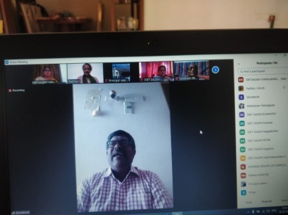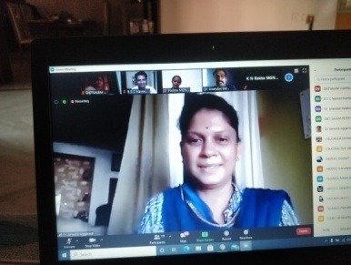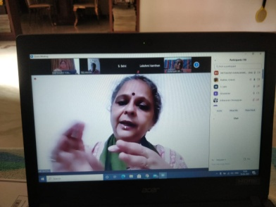

PRE - SERVICE TEACHER EDUCATION:(PSTE)
Dr.P.GOVINDAPRAKASH, SENIOR LECTURER
- 3.5.21 to 5.5.21 - AR Documentation.
- 6.5.21-50% Documentation Work.
- 7.5.21 - Work From Home10.5.21 To 31.5.21 Lockdown.
- 7.6.21 to 8.6.21 - AR Documentation Work From Home.
- 9.6.21- 35% - AR- DIET Tiruvanamalai model Abstract Preparation.
- 10.6.21 to 11.6.21 - AR Documentation Work at Home.
- 14.6.21-33% DIET AR Abstract Preparation Work.
- 15.6.21 - AR Document Consolidation Work.
- 16.6.21 - AR Documentation Work.
- 17.6.21 - DIET AR Abstract Preparation Work.
- 18.6.21- AR DocumentWork -Work From Home.
- 21.6.21 - AR-Consolidation Work.
- 22.6.21- DIET AR Abstract Preparation Work mail sent to DIET Tiruvanamalai.
- 23.6.21 to 24.6.21 Research Consolidation Work.
- 28.6.21 - 50% DIET AR Documentation Work
- 29.6.21 -Research Documentation Work
- 306.21 - 50 % DIET Research Documentation Work

Mrs. M.MAHALAKSHMI,LECTURER

3.5.2021 | Research Document Submitted.  Research Abstract Prepared.
18.6.2021 | 6thStd MCQ’s Preparation Work.
21.6.2021 | 6THMathamatics 100 MCQ’s Preparation Work.
22.6.2021 | 100 MCQ’s For 6thStd Verification Work.
25.6.2021 | 6th Mathamatics Question Verification Work.
29.6.2021 | Cross Verification 6th Mathamatics 100 MCQ -Preparation Work With Dr K.Kannaki.
30.6.2021 | Story Telling Training

Dr. S.PETTER ANANDH, LECTURER
- 3.5.21-Ethics and Indian Culture Preparatory Work.
- 7.5.21-Ethics And Indian Culture Proprietary Work.
- 1.6.21 To 30.6.21-Prepared Video Lesson For Ethics And Indian Culture Carried Out Video Shooting Editing And Presented To DIET - Mannarkudi.

IN-SERVICE FIELD INTERACTION INNOVATION AND COORDINATION :( IFIC)
DATE
06-05-2021-TAMIL  06-05-2021- ENGLISH  10-05-2021-MATHAMATICS  11-05-2021-SCIENCE  12-05-2021- SOCIAL SCIENCE | Organized Video Shooting Work shop For the Preparation Of Workbook Videos - Class-5 For Kalvi  TV.  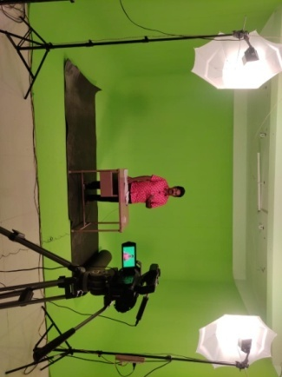
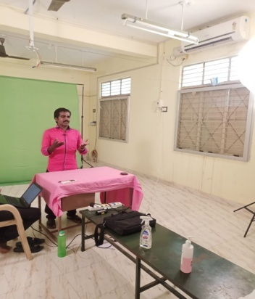 | 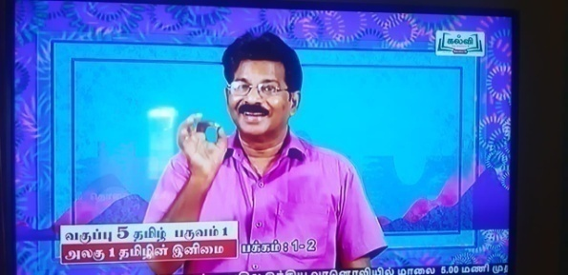

- 1.6.21 to 2.6.21- Research Documentation.
- 3.6.21-Selaction of Resource Person for PG Teachers.
- 4.6.21-Online Meeting for PG Training.
- 7.6.21 to 8.6.21- PG Training Work.
- 9.6.21- Online Meeting for PG Teachers.
- 10.6.21 to 11.6.21-PG Training Work.
- 14.6.21-Research Documentation.
- 15.6.21- Meeting for Conducting PG Training Online Video Shooting for PG Module.
- 16.6.21-Preparation of Expert List for Each Unit.
- 17.6.21-Coordinating Module Preparation for PG Training.
- 18.6.21-Arrangement for PG Training Workshop.
- 19.6.21-Arrangement for PG Training Work.
- 20.6.21- Sunday, Research Project Documentation.
- 21.6.21-PG Training Module Preparation.
- 22.6.21-Research Document Preparation and Binding.
- 23.6.21-PG Teachers Training Digital Content Preparation Meeting.
- 24.6.21-PG Training Module Correction.
- 25.6.21-PG Training Module Correction and Meeting And Video Shooting.
- 26.6.21- Zoology Video Shooting at Sulthan Ismail - Chennai.
- 27.6.21-Sunday- Video Editing Work.
- 28.6.21-BEE Expert Arrangement.
- 29.6.21-BEE Module Preparation.
- 30.6.21- BEE-Module Submitted To SCERT - JD Director Review Meeting.

EDUCATIONAL TECHNOLOGY BRANCH: (ET)
Mrs . G.DHANAMMAL, SENIOR LECTURER
DATE | WORK DONE
12.5.21 | Reviewed the Social Science Video Shooting and Editing Work.
17.5.21  to  18.5.21 | Reviewed the Social Science 5th Std Videos and Editing Work.
30.6.21 | Participated International Workshop On Story Telling.

Dr.V.SUGANYA, LECTURER
DATE | WORK DONE
3.5.2021 | Newsletter Preparation Work.
4.5.2021 to 5.5.2021 | PPT Preparation for Science Video Shooting.
6.5.2021 | Foundation Literacy And Numeracy Suggestion And Feedback.
7.5.2021 | Workbook Video Shootting For 6thScience.
8.5.2020 to 31.5.2021 | Science Work Book Video Review Work at Home.  Basic Civil Engineering Refresher Course Coordination.
24.06.2021 | Newsletter preparation Work.
25.06.2021 | Attending JD (Syllabus) Regarding Refresher Course Module Preparation.
28.06.2021 | News Letter Preparation Work.  Attending JD (Syllabus) Meeting Regarding MCQ’s For BCE.
30.06.2021 | Attended International-Story Telling Workshop.

DISTRICT RESOURCE UNIT: (DRU)
NAME OF THE DIET FACULTY: Dr P.SO.KESAVAN, DRU BRANCH

Date | DETAILS OF WORK CARRIED OUT
18.5.2021 | ATTENDED ON-LINE MEETING: SAP/ VENTEL &COVID WARRIORS ACTION PLAN
2.6.2021 | ATTENDED -SCERT JD MEETING-REGARDING CLASS XI REFRESHER COURSE MATERIAL PRPARATION THROUGH GOOOLE MEET.
11.6.2021 | II BATCH : DIET: SWAYAM FORTHCOMING COURSE DETAILS COLLCECTED-REPORT PREPARED AND SUBMITTED TO THE PRINCIPAL.
16.6.2021 | II BATCH : DIET:ACTION RESEARCH -ABSTRACT PREPARED IN THE GIVEN FORMAT AND SUBMITTED TO PSTE BRANCH MAIL.

CURRICULUM MATERIAL DEVELOPMENT AND EVALUVATION :( CMDE)
Dr. R. NAGALAKSHM , SENIOR LECTURER
- Prepared and Finalized Chemistry Worksheets with Question and Answers from Reduced Syllabus On 03/05/2021 & 04/05/2021.
- Draft Guidelines On Foundational Literacy And Numeracy Prepared By NCERT – Was Reviewed to Give Feedback And Suggestions (Chapter Wise) On 05/05/2021 & 06/05/2021.
- Participated In SAP VENTEL Programme-ZOOM On 18/05/2021.
- Attended Zoom Meeting for Preparation of Refresher Course Module for Chemistry Class 12thon 03/06/2021, 11/06/2021 & 16/06/2021 Conducted By JD-SCERT.
- Created Resource Group of Post Graduate Teachers Handling Chemistry And Carried Out The Process Of Preparing Content For Refresher Course Module.

Mrs. B.ANANTHI, LECTURER
- Coordinated Refresher Course Module for English Standard 1- 4 From 01/05/2021 To 31/05/2021.
- Prepared Additional Activities for Refresher Course Module For Classes 1-5 From 08/06/2021 To 11/06/2021.

PLANNING AND MANAGEMENT: (P&M)
Dr. K.KANNAKI, SENIOR LECTURER
- Bridge Course Video Shooting Review Work f or Primary Mathematics.
- 6thStandard Mathematics Term Wise Multiple Choice Questions Review Work.
- 6thStandard Mathematics 100 Multiple Choice Questions Preparation Work For Term - 1.

WORK EXPERIENCE: (WE)
NAME OF THE DIET FACULTY: Dr S.V. VIJAYALAKMI SHANKAR,
SENIOR LECTURER, WE BRANCH
Date | ACTIVITIES
May 2021  Lock Down | BCE -XII Standard-Question and Answer Preparation -Coordination Work.  Attended SAP Programme Through Zoom Metting.  VENTAL Cell Programme-Coordinated- Meeting Conducted By MGNCRE.
01.6.2021 | Research Project Work
05.6.2021 | Research Project Work
06.6.2021 | Research Project Work
08.6.2021 | Research Project Work
9.6.2021 | Research Project Work
12.6.2021 | Research Project Work
15.6.2021 | Research Project Work
16.6.2021 | Research Project Work
19.6.2021 | DRC -Research Project Submission -Rough Draft
20.6.2021 | DRC -Research Project Submission -Rough Draft
21.6.2021 | VENTAL Cell -Meeting Conducted by Principal
22.6.2021 | Research Project -Documentation Work
23.6.2021 | Research Project -Documentation Work

Chief Editor : Dr M.SELVAM, PRINCIPAL
UTHAMACHOLAPURAM,
SALEM-636010
Associate Editors : G.DHANAMMAL (SL),
M. Jayamani (L),
Editor : S. Selvi(L)
This Newsletter is Prepared and Published by ET Branch
Phone : 73730 03460
e-mail : dietslm@gmail.com
Visit : www.dietsalem.in

